Moreno, Melissa

February 26, 2019

SUR5386

Tutorial 4

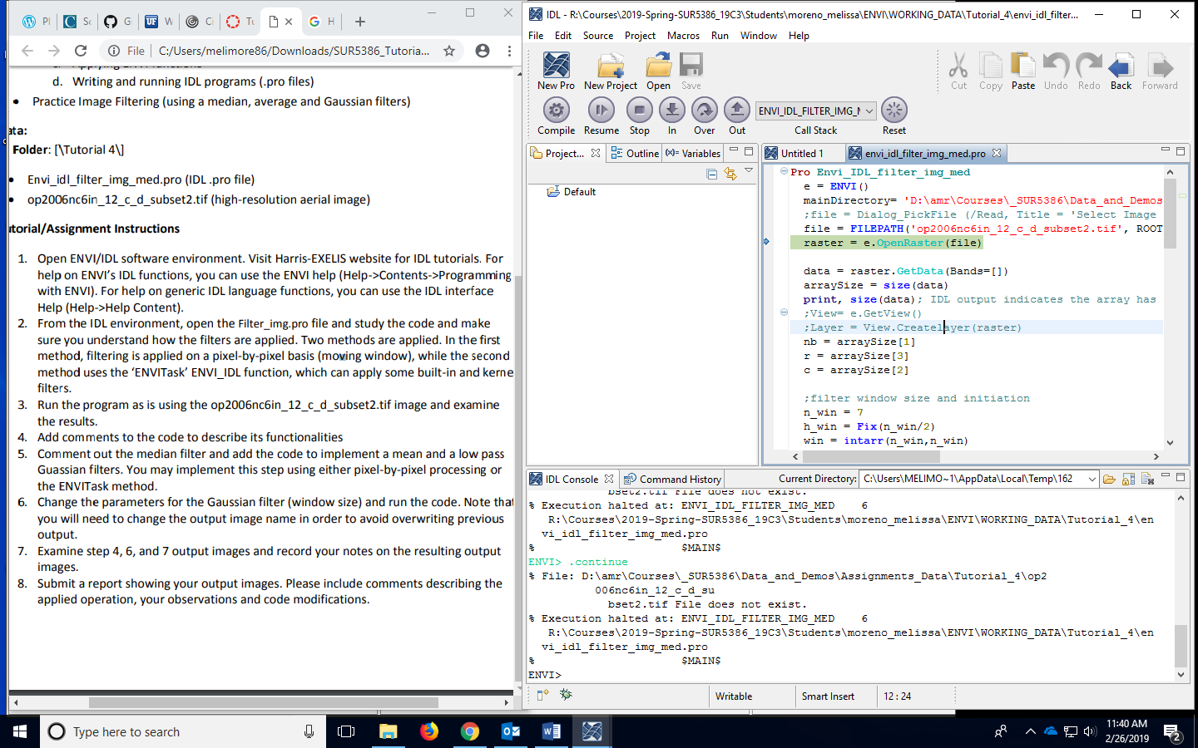2. Opening up the Filter_img.pro file and looking at the different codes.

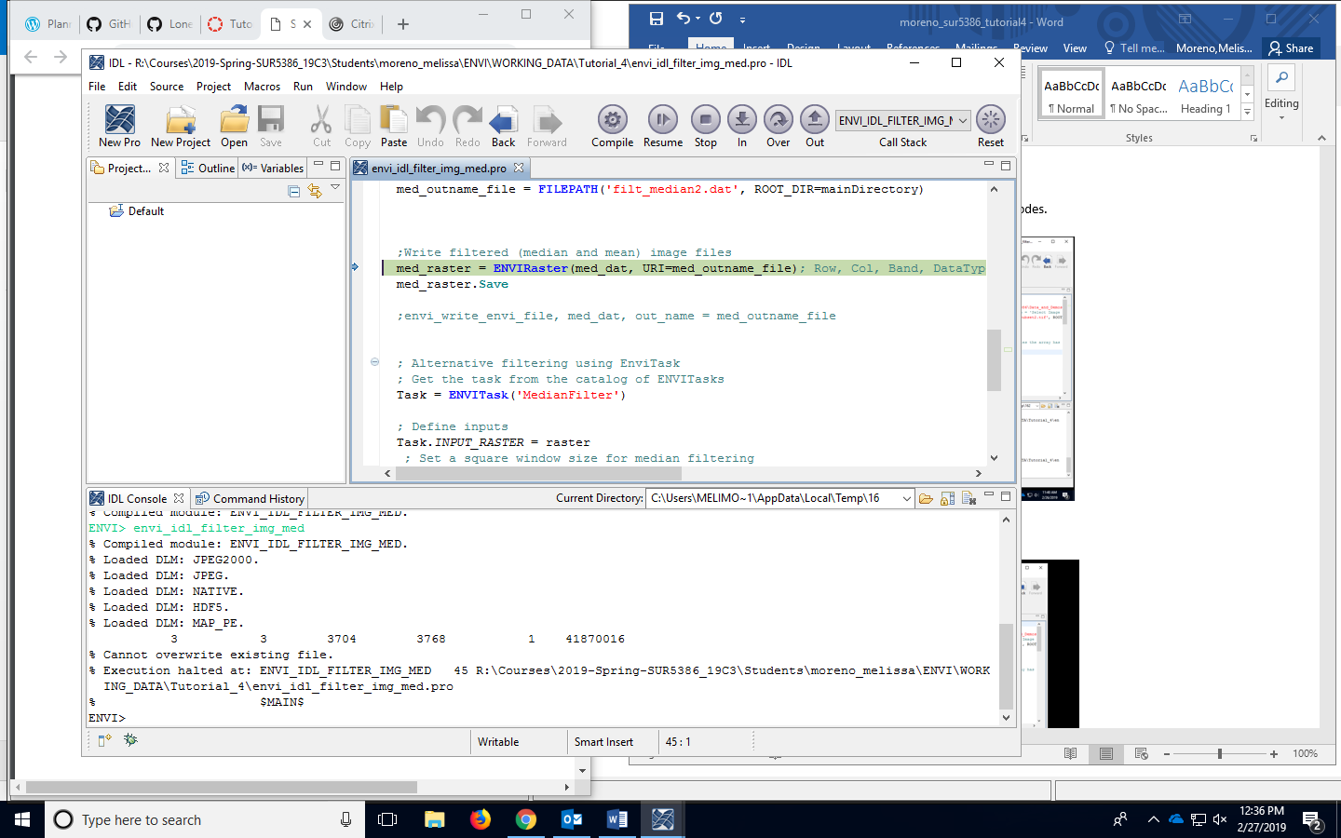3. Compiling and running the program.

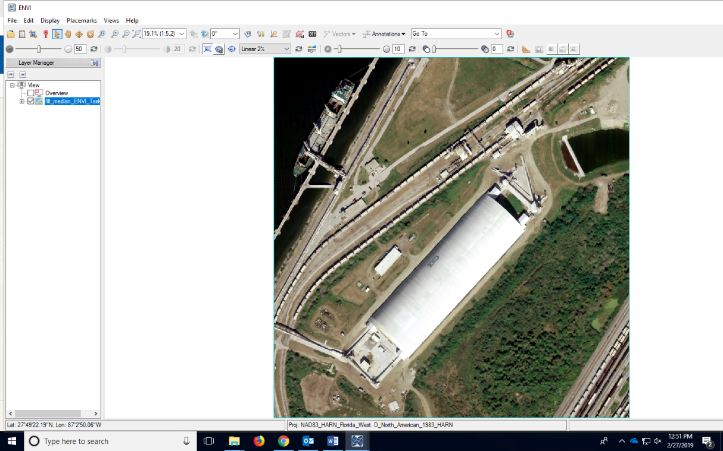Examining the results. This is the median filter applied to the original image.

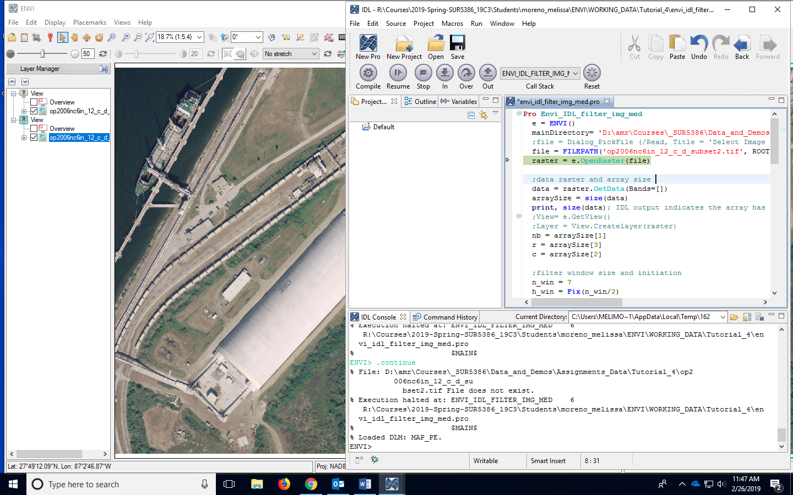4. Added comments, even though most of the code can comments already.

5. Commenting out the median filter and adding the Gaussian Low Pass filter. Used the Envi task command that allows you change the filter that you want to add to the image.

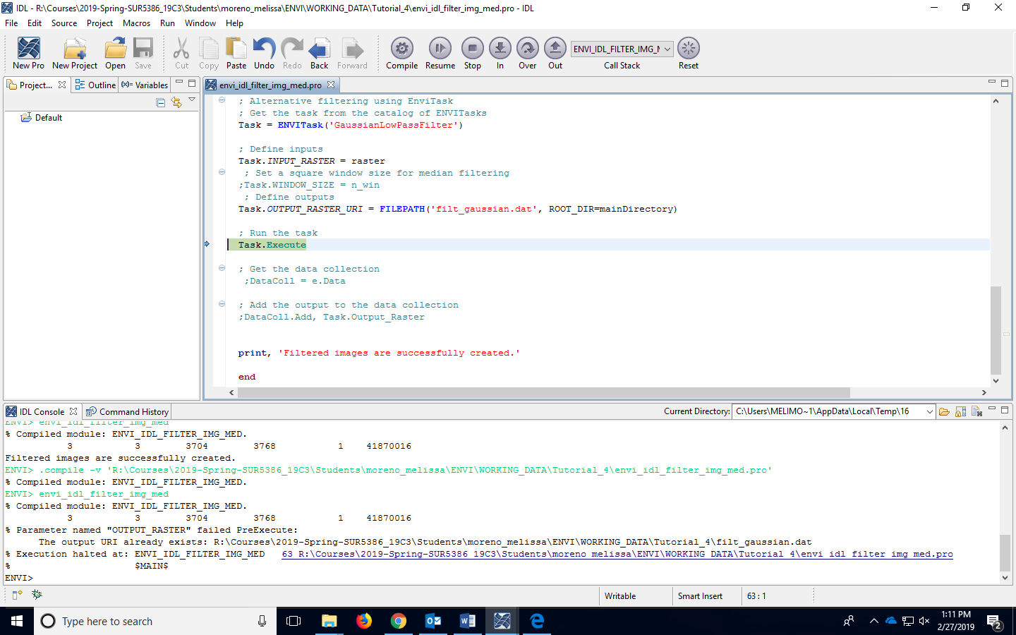

Left is median filter, and right is the Gaussian low pass filter. 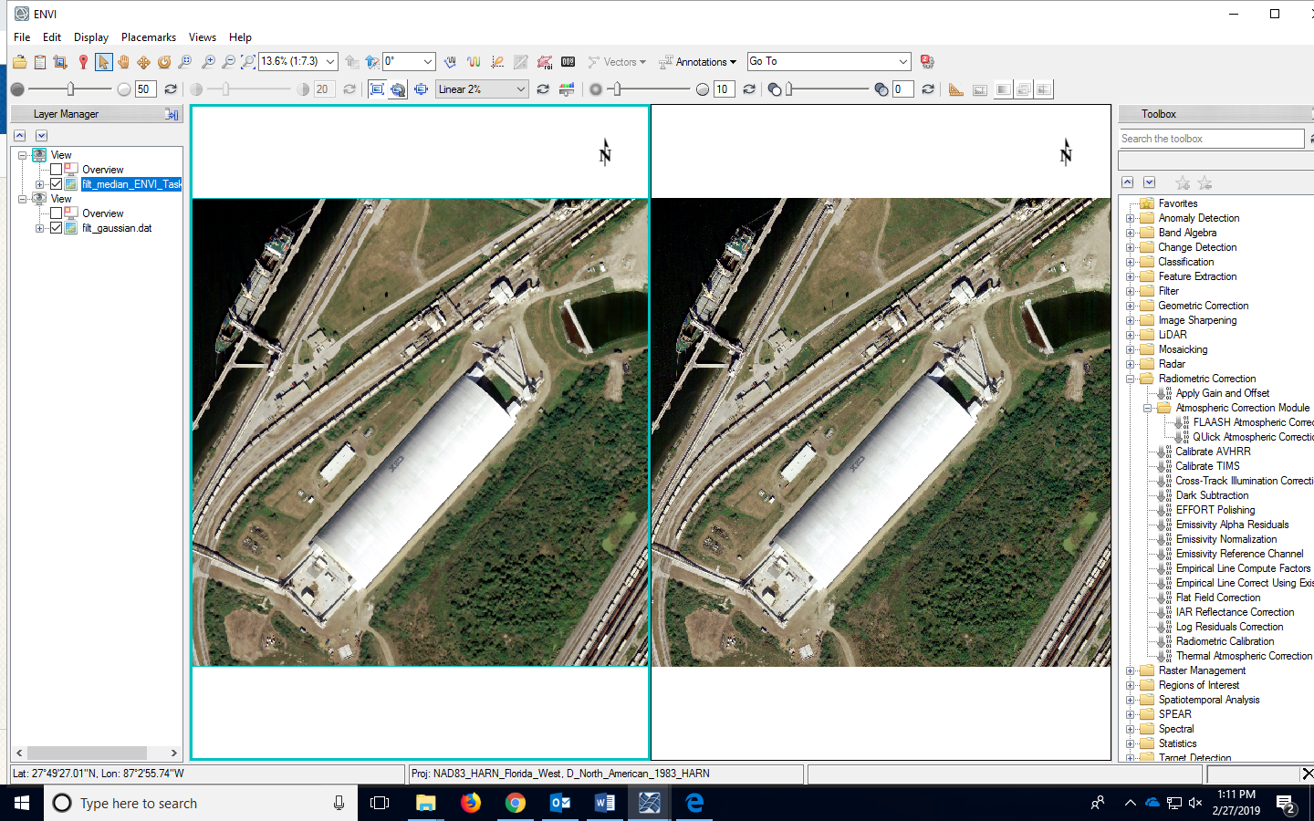

Horizontal profiles for each image on the same pixel. We can see that the Gaussian is following the same curve but slightly different intervals in the curve. They appear to be very similar.

